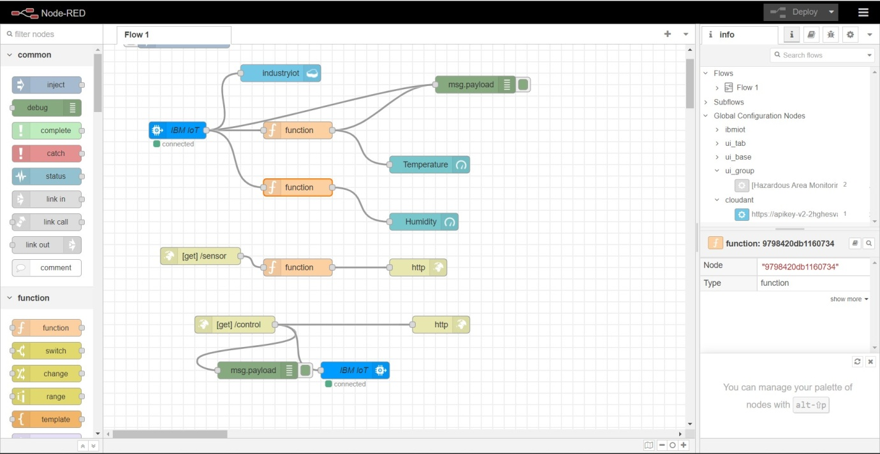**Develop The Web Application Using Node-RED**

|  |  |
| --- | --- |
| Date | 17 nov 2022 |
| Team Id | PNT2022TMID46546 |
| Title | Hazardous Area Monitoring for Industrial Plant using IoT |

**Node red flow**

**Function blocks**

